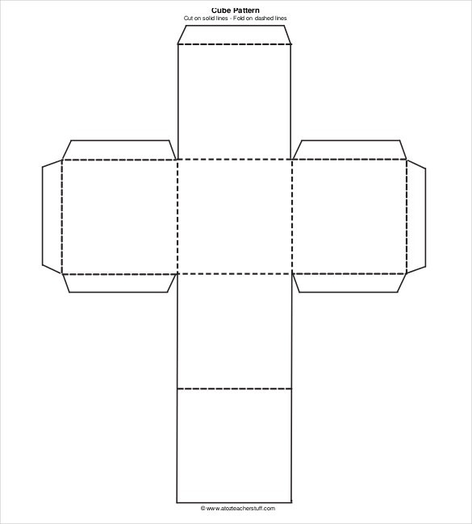

**#4**

**What good can we do around here?**

**#1**

**How did you see God work in your life this week?**

**#2**

**What has God been teaching you in His Word?**

**#5**

**How can we help you in prayer?**

**#6**

**Pick whatever question you want to answer!**

**#3**

**Who have you been talking to who doesn’t know Jesus yet?**